Case 6- DR Congo-Luba-Hemba-Stool-King and Queen Mother-Caryatid-Wood-mid 19th c

Note: The Democratic Republic of the Congo (DR Congo) has been known as, in chronological order, the Congo Free State, Belgian Congo, the Republic of Congo-Léopoldville, the Democratic Republic of the Congo and the Republic of Zaire, before returning to its current name the DR Congo.

Note: The Kongo people (singular: Mukongo, pl. Bakongo) speak Kikongo, a Bantu language, who have lived along the Atlantic coast of Central Africa, in a region that, by the 15th century, was a centralized and well-organized Kongo Kingdom but is now a part of three countries: the Democratic Republic of the Congo, the Republic of the Congo and Angola.

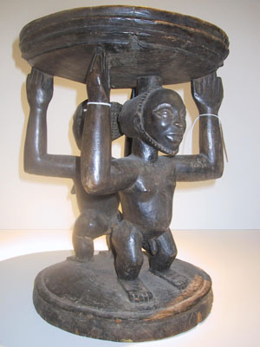

Figs. 1-2. Congo DR-Luba-Hemba-Stool-King and Queen Mother-Caryatid-Wood-mid 19th c

**LC Classification: N1099.C6**

**Date or Time Horizon:**

**Geographical Area:**

**Map:**

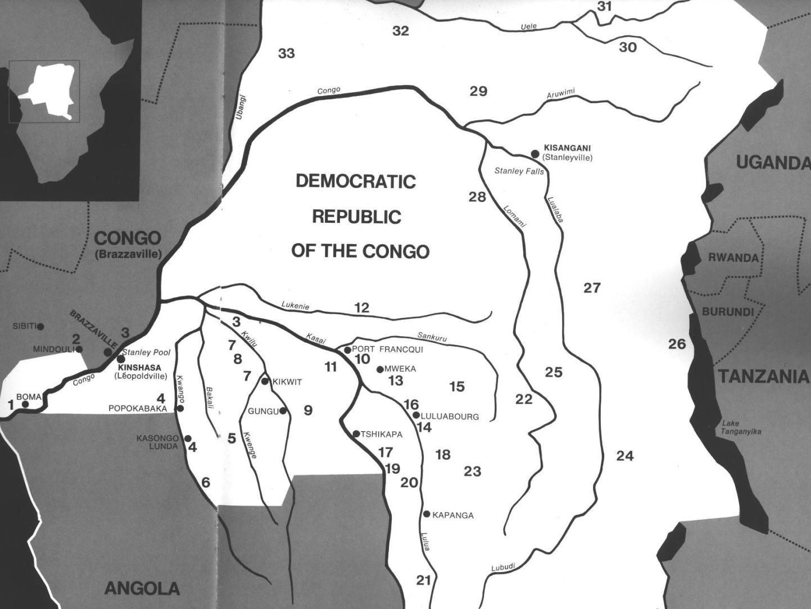

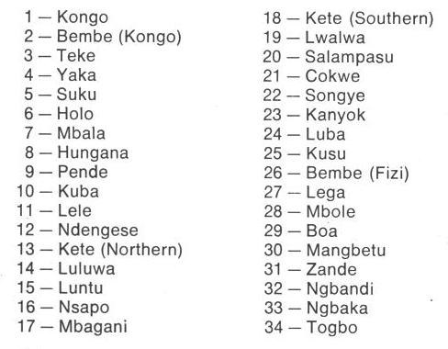

Fig. 1. Map of Kongo Cultures, West Central Africa. After Walker Art Center 1967. 9 is Pende.

**Case No.:**

**Accession Number:**

**Formal Label:**

**Display Description:**

A caryatid stool (depicted above) with a dark patina sold in 2004 for $18,000 by the Titus Gallery, 222 The Commons, Ithaca, NY, having the following data: “A rare Hemba/Luba double figure caryatid stool. The fine, varied, dark patina and wear is consistent with many years of use. Origin:  Zaire; Height:  16.75 inches; Provenance:  Stuart J. Warkow, SMA Fathers Missionary Museum, Titus Gallery. $18,000.” Ref.: Nooter et al. 1996.

**GPS coordinates:** 7° 46' 19.3" (7.772°) S, 24° 17' 44.9" (24.2958°) E

**Cultural Affiliation:** Pende, Central Bantu

**Media:** wood, raffia, kaolin, ferruginous earth

**Dimensions:** H 20.866 in

**Weight:** 2.52 pounds

**Condition: original**

**Provenance:** Kitangwa

**Discussion:**

**References:**

Adams, Monni. 1988. 8th century Kuba king figures, *African Art* 21(3): 32-38, 88.

Belepe, Bope. 1974. *Etude socio-morphologique des masques Bwoom des Kuba: Memoire de licence en histoire.* Lubumbashi: Université Nationale du Zaire.

Belepe, Bope. 1981. Les oeuvres plastiques Africaines comme documents d'histoire: Le cas des statues Royales Ndop des Kuba du Zaire, *Africa­Tervuren* 25(1): 9-17.

Binkley, D. 1987. Avatar of power: Southern Kuba masquerade figures in funerary context, *Africa* 57 (1).

Binkley, D. 1990. Masks, space and gender in southern Kuba initiation ritual, *Iowa Studies in Art.* Vol. 3, *Art and Initiation in Zaire.* Iowa City: The University of Iowa.

Brett-Smith, Sarah. 1983. “The Doyle Collection of African Art,” *Record of the Art Museum, Princeton University*, 42(2): 2+8-34.

Kuba du Zaire, Africa­ Tervuren 27(1): 9-17.

Binkley, D. 1987. Avatar of power: Southern Kuba masquerade figures in funerary context, *Africa* 57 (1).

Binkley, D. 1990. Masks, space and gender in southern Kuba initiation ritual, *Iowa Studies in Art.* Vol. 3, *Art and Initiation in Zaire.* Iowa City: The University of Iowa.

Claerhout, A. 1976. Two Kuba wrought-iron statuettes, *African Art* IX (4): 60-64.

Cornet, J. 1972. *Art de l'Afrique Noire au pays du fleuve Zaire*. Brussels: Arcade.

Cornet, J. 1975. *Art from Zaire: 100 Masterworks from the National Collection.* New York: African-American Institute.

Cornet, J. 1982. *Art royal Kuba.* Milan: Sipiel.

Ehret, Christopher. 2002. *The civilizations of Africa: a history to 1800*. Charlottesville: Virginia: University of Virginia Press.

Forbath, Peter. 1977. *The River Congo*. Boston: Houghton Mifflin.

Laman, Karl. 1953. *The Kongo*. 4. vols. Stockholm: Victor Pettersons.

MacGaffey, Wyatt. 1986. *Religion and society in central Africa: the Bakongo of Lower Zaire*. Chicago: University of Chicago Press.

MacGaffey, Wyatt. 1988. “Complexity, astonishment and power: the visual vocabulary of Kongo minkisi,” *Journal of African Studies*, (14:2), 188-203.

Martinez-Ruiz, Barbaro. 2013. *Kongo Graphic Writing and other Narratives of the Sign*. Philadelphia: Temple University Press.

Nooter, M. N. and A. F. Roberts, *Memory, Luba Art and the Making of History*. Munich: Prestel.

Rosenwald, J. B. 1974. “Kuba king figure,” *African Art,* VII (3).

Schadeberg, Thilo. 1999. “Batwa: the Bantu name for the invisible people.” In *Challenging Elusiveness: Central-African Hunter Gatherers in a Multidisciplinary perspective*, ed. K. Beibrouck, S. Elders, and G. Rossel. Leiden: CNWS, 21-39.

Thompson, Robert Farris. 1978. “The Grand Detroit N’kondi,” *Bulletin of the Detroit Institute of Arts* 56 :4, 206-217.

Torday, E. and T. A. Joyce. 1911. « Notes ethno­graphiques sur les peuples communement appeles Bakuba, ainsi que sur les peuplades apparentees, les Bushoongo. » In *Annales du Musee Royal du Congo Belge, Ethnographie et Anthropologic.,* serie III, tome II, fasc. 1. Brussels: Tervuren.

Vansina, Jan. 1955 “Initiation Rituals of the Bushong,” *Africa* 25(2): 138-153.

Vansina, Jan. 1964. *Le royaume kuba.* Tervuren: Musée royal de l'Afrique centrale.

Vansina, Jan. 1978. *The children of Woot. A history of the Kuba peoples.* Madison: University of Wisconsin Press/Dawson.

Vansina, Jan. 1984. *Art History in Africa.* London: Longman.

Van Wing, Joseph Hubert Leopold. 1941. *Études Bakongo*. II. *Religion et magie*. Institut royal colonial belge. Section des sciences morales et politiques. Mémoires, collection in-8°, t. IX, fasc. 1. Brussels: Desclée de Brouwer.

Van Wing, Joseph Hubert Leopold. 1959. *Études Bakongo.* Brussels: Desclée de Brouwer.

Walker Art Center. 1967. *Art of the Congo*. Minneapolis: Walker Art Center.

Luba are one of the oldest Bantu-speaking cultures in south-central DR Congo who organized a Kingdom of Luba in the Upemba or **Kamalondo Depression** of Central Africa.[[3]](https://en.wikipedia.org/wiki/Luba_people#cite_note-Falola285-3)[[4]](https://en.wikipedia.org/wiki/Luba_people#cite_note-Reefe1981p67-4)

Access to a variety of mineral resources together with skills in metal smithing, ivory carving, wood carving, pottery, and jewelry established their predominance in the area by the 5th c CE.[[5]](https://en.wikipedia.org/wiki/Luba_people#cite_note-Appiah2010p88-5)[[6]](https://en.wikipedia.org/wiki/Luba_people#cite_note-bortolot-6) By the ninth c CE they had expanded their empire throughout the region. The Luba developed a governance network with a central ruler who succeeded through the mother's line.

Much more is known about the Luba than many of the other tribes on the African continent due to the way that they used intricate works of art called "lukasa" and other memory devices to record their history and fundamental precepts about Luba kingship in which Luban art is used to encode the complex structure of sovereign rule within their empire using memory as a dynamic, creative facility.

Their success and wealth grew in relative isolation, given their forested mountainous inland location, then attracted traders, raids and wars in second half of the 19th century.[[7]](https://en.wikipedia.org/wiki/Luba_people#cite_note-Reefe1981p159-7) The Luba people were victims of the slave and ivory trade, both the Atlantic coast's Portuguese slave traders, as well as to the east African coast by Swahili-Arab slave traders, particularly during the 19th century.[[5]](https://en.wikipedia.org/wiki/Luba_people#cite_note-Appiah2010p88-5)[[8]](https://en.wikipedia.org/wiki/Luba_people#cite_note-Reefe1981p147-8)

Elizabeth Heath (2010). Anthony Appiah; Henry Louis Gates, eds. [Encyclopedia of Africa](https://books.google.com/books?id=A0XNvklcqbwC). Oxford University Press. pp. 88–89, 14–15.

**M. N. Nooter and A. F. Roberts, *Memory, Luba Art and the Making of History*. Munich: Prestel, 1996**

Appendix: